For Immediate Release

Hong Kong Genome Institute Garners “Outstanding Gold Award”
at Privacy-Friendly Awards 2025

(Hong Kong, 10 July 2025) – The Hong Kong Genome Institute (HKGI) is dedicated to accelerating the development of genomic medicine through the Hong Kong Genome Project (HKGP), the city’s first large-scale whole genome sequencing initiative. In its efforts to foster precision medicine and enhance public health outcomes, HKGI is pleased to announce that it has received the Outstanding Gold Award, the highest honour at the "Privacy-Friendly Awards 2025" organised by the Office of the Privacy Commissioner for Personal Data (PCPD), recognising the Institute’s exemplary performance across five designated “Privacy Protection Measures”. This accolade is a testament to HKGI's unwavering commitment to safeguarding the personal information and data security of HKGP participants while advancing the frontiers of genomic medicine.

Mr Philip Tsai Wing-Chung, Chairperson of HKGI, remarked, "We are deeply honoured to receive this prestigious Outstanding Gold Award, which highlights the dedication and effectiveness of our team in safeguarding privacy and data security. Each person’s genomic data is unique and invaluable. In this era of artificial intelligence and big data, the stringent management and protection of such information are of paramount importance. To this end, HKGI remains committed to staying at the forefront of technological advancements to further strengthen our data security measures, continuously striving for excellence in our operations."

Dr Lo Su-vui, Chief Executive Officer of HKGI, added, "Receiving the Outstanding Gold Award affirms the dedication and achievements of each and every one of our colleagues in privacy and data protection. As the HKGP continues to expand, we have already put in place rigorous policies and procedures for data security and management. In addition to the strict implementation of all relevant protocols and measures, we also conduct regular risk assessments and continuously optimise our hardware and software systems. Upholding our professional ethos, we will remain steadfast in our dedication to maintaining the highest standards and committed to protecting the personal information and data security of both the Institute and HKGP participants."

The "Privacy-Friendly Awards" is organised by PCPD to recognise and commend organisations for their efforts in protecting personal data privacy. The award is assessed based on five “Privacy Protection Measures”, in which HKGI demonstrated award-winning excellence: 1) Discussion of data security policies or review of the implementation of data security measures at board meetings and/or senior management meetings; 2) Appointment of at least one Data Protection Officer or a dedicated department for data protection; 3) Completion of PCPD's Data Security Scanner; 4) Development of a data breach response plan; and 5) Provision of training or education for staff on the protection of personal data privacy.

For more information about HKGP and related data protection and security measures, please visit HKGI's website at www.hkgp.org.

Photo Caption:

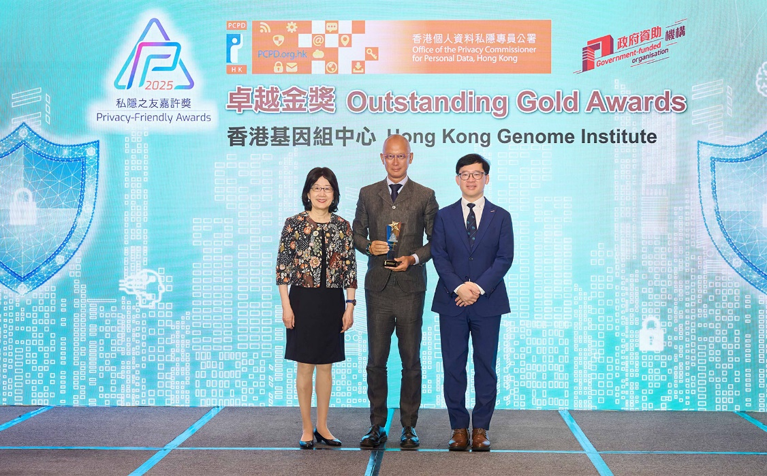
Hong Kong Genome Institute has received the highest honour
“Outstanding Gold Award” at the "Privacy-Friendly Awards 2025".
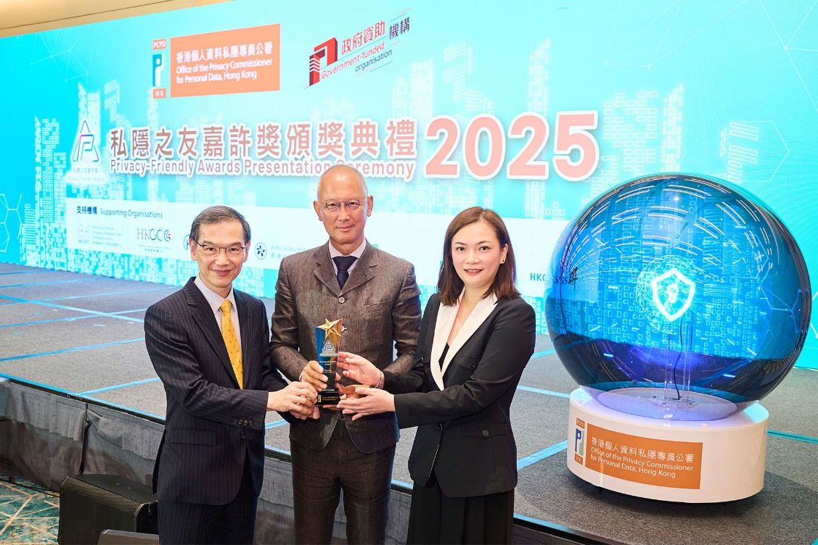
Hong Kong Genome Institute Chairperson Mr Philip Tsai Wing-chung (centre),
CEO Dr Lo Su-vui (left), and Head of Operations (Scientific Branch) Dr Annie Chu Tsz-wai (right) attended the Award Ceremony to celebrate the momentous achievement.

[End]

About Hong Kong Genome Institute

The Hong Kong Genome Institute (HKGI), established and wholly owned by the Hong Kong SAR Government, commenced full operations in 2021. With the vision “to avail genomic medicine to all for better health and well-being” and supported by the Health Bureau, HKGI works in close collaboration with the Department of Health, Hospital Authority, medical schools of local universities and other stakeholders to accelerate the development of genomic medicine in Hong Kong along four strategic foci: integrate genomics into medicine, advance research, nurture talents and enhance public genomic literacy.

As the first step towards achieving its vision, HKGI launched the Hong Kong Genome Project (HKGP) in 2021 focusing on diseases and research cohorts that would benefit from whole genome sequencing. They include undiagnosed diseases, hereditary cancers and cases related to genomics and precision health. Being the city’s first large-scale genome sequencing project, HKGP serves as a catalyst to benefit patients and their families with more precise diagnosis and personalised treatment. It also aims to establish genome database of the local population, testing infrastructure and talent pool to address the healthcare needs of Hong Kong in the long run.

For more information, please visit https://hkgp.org/en.

